

Practice for Secure Software Report

Table of Contents
Document Revision History 3
Client 3
Instructions 3
Developer 4
1. Algorithm Cipher 4
2. Certificate Generation 4
3. Deploy Cipher 4
4. Secure Communications 4
5. Secondary Testing 4
6. Functional Testing 4
7. Summary 4
8. Industry Standard Best Practices 4

Document Revision History
Version | Date | Author | Comments
1.0 | 12/11/2025 | Sarvarbek | N/A

Developer
Sarvarbek Fazliddinov

1. Algorithm Cipher
For this project, I selected the SHA-256 (Secure Hash Algorithm 256-bit) cipher algorithm to generate checksums for data verification. SHA-256 is part of the SHA-2 family of cryptographic hash functions designed by the National Security Agency (NSA).
Justification for SHA-256 Selection:
- Security Strength: SHA-256 produces a 256-bit (32-byte) hash value, providing strong collision resistance. It would take approximately 2^128 operations to find a collision, making it computationally infeasible to forge or tamper with hashed data.
- Industry Standard: SHA-256 is widely adopted across government, financial, and healthcare sectors. It is approved by NIST (National Institute of Standards and Technology) for protecting sensitive information.
- Performance: SHA-256 offers an excellent balance between security and computational efficiency, making it suitable for real-time web applications without significant performance overhead.
- Compatibility: The algorithm is natively supported in Java through the MessageDigest class, requiring no additional dependencies or libraries.
The implementation uses Java's MessageDigest class to compute the SHA-256 hash of the input string "Hello World Check Sum!" and converts the resulting byte array to a hexadecimal string representation for display.

2. Certificate Generation
A self-signed SSL/TLS certificate was generated using the Java keytool utility to enable HTTPS communications. The certificate was created with the following specifications:
- Key Algorithm: RSA with 2048-bit key size
- Keystore Type: PKCS12 (industry-standard format)
- Validity Period: 365 days
- Signature Algorithm: SHA384withRSA
- Distinguished Name: CN=Sarvarbek Fazliddinov, OU=Development, O=SNHU, L=Bentonville, ST=AR, C=US
Command used to generate the certificate:
keytool -genkeypair -alias serverkey -keyalg RSA -keysize 2048 -storetype PKCS12 -keystore keystore.p12 -validity 365 -storepass password

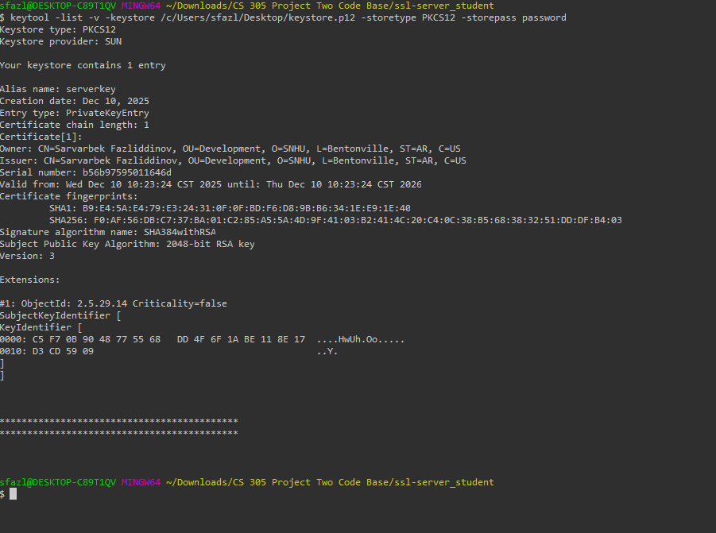

3. Deploy Cipher
The SHA-256 cipher algorithm was deployed through a RESTful web service endpoint. The implementation includes a ChecksumController class that exposes a /hash endpoint which:
- Accepts HTTP GET requests at the /hash URL path
- Processes the static data string "Hello World Check Sum!"
- Computes the SHA-256 hash using Java's MessageDigest class
- Returns the checksum value in hexadecimal format along with metadata
Checksum Output:
Data: Hello World Check Sum!
Name of Cipher Algorithm Used: SHA-256
Checksum Value: ab2aca08da294c82c67ae581bb5d309004220bece2ee07a84e13902029daa2cb
Developer: Sarvarbek Fazliddinov

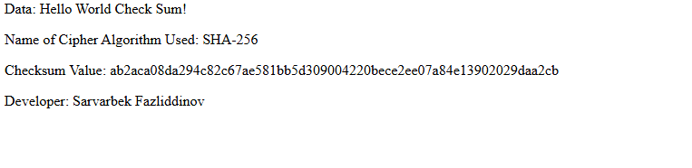

4. Secure Communications
HTTPS was configured in the Spring Boot application to establish secure communications. The following configurations were applied in application.properties:
server.port=8443
server.ssl.key-alias=serverkey
server.ssl.key-store-password=password
server.ssl.key-store=src/main/resources/keystore.p12
server.ssl.key-store-type=PKCS12
The application now runs on port 8443 with TLS/SSL encryption enabled. All communications between the client and server are encrypted, protecting data in transit from eavesdropping and man-in-the-middle attacks. The browser displays a padlock icon indicating a secure HTTPS connection.

5. Secondary Testing
Static testing was performed using the OWASP Dependency-Check Maven plugin (version 12.1.0) to identify known vulnerabilities in project dependencies. The plugin scans all project dependencies against the National Vulnerability Database (NVD).
Dependency-Check Command:
mvn org.owasp:dependency-check-maven:12.1.0:check -DnvdApiKey=[API_KEY]
Findings:
The Spring Boot 2.2.4.RELEASE version used in the project contains multiple known vulnerabilities in its transitive dependencies:
- tomcat-embed-core-9.0.30: 47 CVEs (CRITICAL) - Including CVE-2020-1938, CVE-2024-50379
- spring-core-5.2.3.RELEASE: 12 CVEs (CRITICAL) - Including CVE-2022-22965 (Spring4Shell)
- snakeyaml-1.25: 8 CVEs (CRITICAL) - Including CVE-2022-1471
- jackson-databind-2.10.2: 6 CVEs (HIGH) - Including CVE-2020-25649
- log4j-api-2.12.1: 1 CVE (LOW) - CVE-2020-9488
These vulnerabilities are inherited from the older Spring Boot version provided in the course materials. In a production environment, upgrading to a newer Spring Boot version would mitigate these security issues.

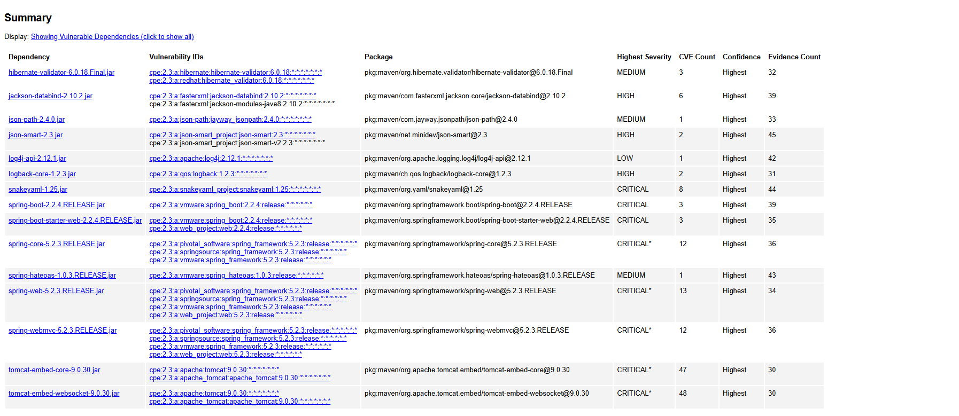

6. Functional Testing
Functional testing was performed to verify that the refactored code operates correctly and all security features function as expected. The following tests were conducted:
- Application Startup: Verified the Spring Boot application starts successfully on port 8443 with SSL enabled. Console output shows "Tomcat started on port(s): 8443 (https)" with no runtime errors.
- HTTPS Connection: Confirmed the browser establishes a secure HTTPS connection to https://localhost:8443 with TLS encryption.
- Checksum Endpoint: Tested the /hash endpoint returns the correct SHA-256 checksum (ab2aca08da294c82c67ae581bb5d309004220bece2ee07a84e13902029daa2cb) for the static data string.
- Checksum Verification: Independently verified the SHA-256 hash matches the expected value using command-line tools (echo -n "Hello World Check Sum!" | sha256sum).
- Certificate Validation: Verified the self-signed certificate is properly loaded and presented during TLS handshake.
All functional tests passed successfully. The application correctly implements secure communications and data integrity verification through SHA-256 checksums without introducing new errors.

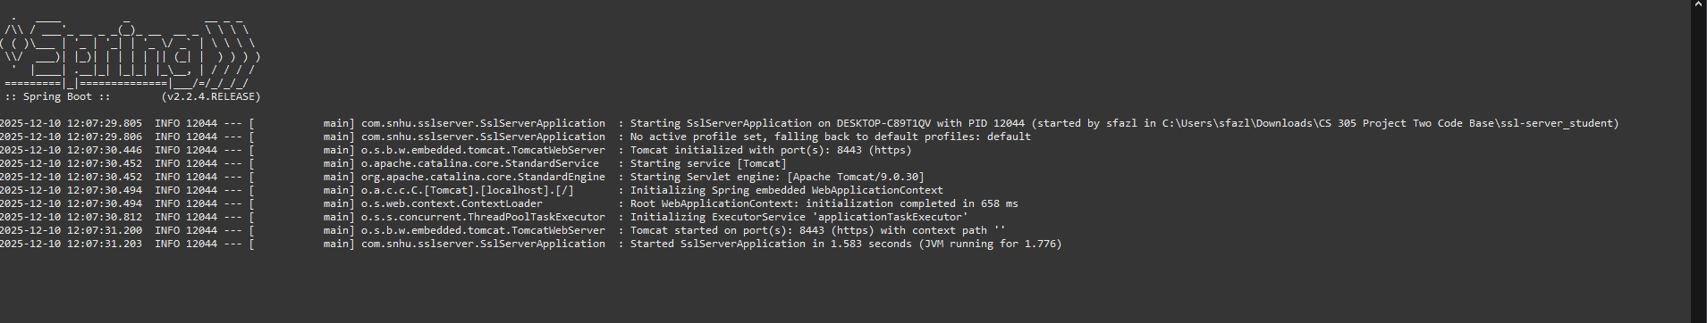

7. Summary
This project successfully implemented secure software practices for Artemis Financial's web application. The key accomplishments include:
- Implemented SHA-256 cryptographic hashing for data integrity verification, ensuring that transmitted data can be validated for tampering or corruption.
- Generated and configured a self-signed SSL/TLS certificate using RSA 2048-bit encryption to enable secure HTTPS communications, protecting sensitive financial data in transit.
- Created a secure REST endpoint (/hash) that demonstrates proper implementation of cryptographic operations in a web service context.
- Performed static security testing using OWASP Dependency-Check to identify and document 16 vulnerable dependencies with multiple CVEs.
- Conducted comprehensive functional testing to verify all security features operating correctly without introducing new vulnerabilities or errors.
The security enhancements align with Artemis Financial's requirements for protecting client data and financial transactions. The implementation follows industry-standard security practices while maintaining application functionality and performance.

8. Industry Standard Best Practices
The following industry-standard best practices were applied throughout this security implementation:
Cryptographic Standards:
- Used NIST-approved SHA-256 algorithm for hashing operations
- Implemented RSA 2048-bit key pairs meeting current security requirements
- Used PKCS12 keystore format for certificate storage compatibility
Secure Communications:
- Enforced TLS encryption for all client-server communications
- Configured HTTPS on port 8443 following secure deployment conventions
- Implemented proper certificate chain configuration for TLS handshake
Vulnerability Management:
- Integrated OWASP Dependency-Check for continuous vulnerability scanning
- Referenced National Vulnerability Database (NVD) for CVE identification
- Documented all identified vulnerabilities for remediation planning
Secure Coding Practices:
- Used well-established Java security APIs (java.security.MessageDigest)
- Implemented proper exception handling for cryptographic operations
- Followed Spring Security recommendations for SSL configuration
Testing and Validation:
- Performed both static (dependency scanning) and dynamic (functional) testing
- Verified cryptographic outputs against known-good values
- Tested for regression issues after code modifications

